**Assignment_1**

Name : Chilipireddy Hasini Reddy

ID : 700734555

Video Link :

<https://drive.google.com/drive/folders/1gOshSWX1uXd5Aok1_OY7hZZWpeldBc42?usp=sharing>

Github link : <https://github.com/hasinireddych/ML/edit/main/README.md>

Q1

___+__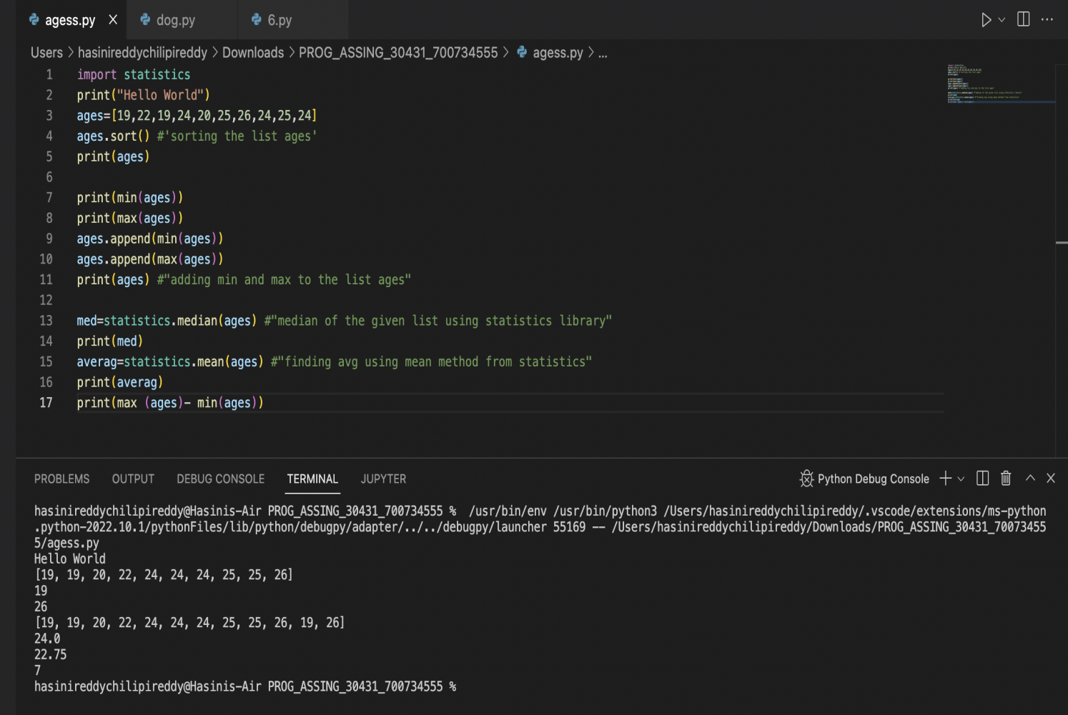

In this question we are sorting the given list using sorting techniques, Finding the min and max age, and adding them to the list using append keyword. We are finding the median age of the given list using the statistics library. Finding the average age using the mean method from statistics by finding out the difference between the max age and min age we can find the range of the given list.

Q2

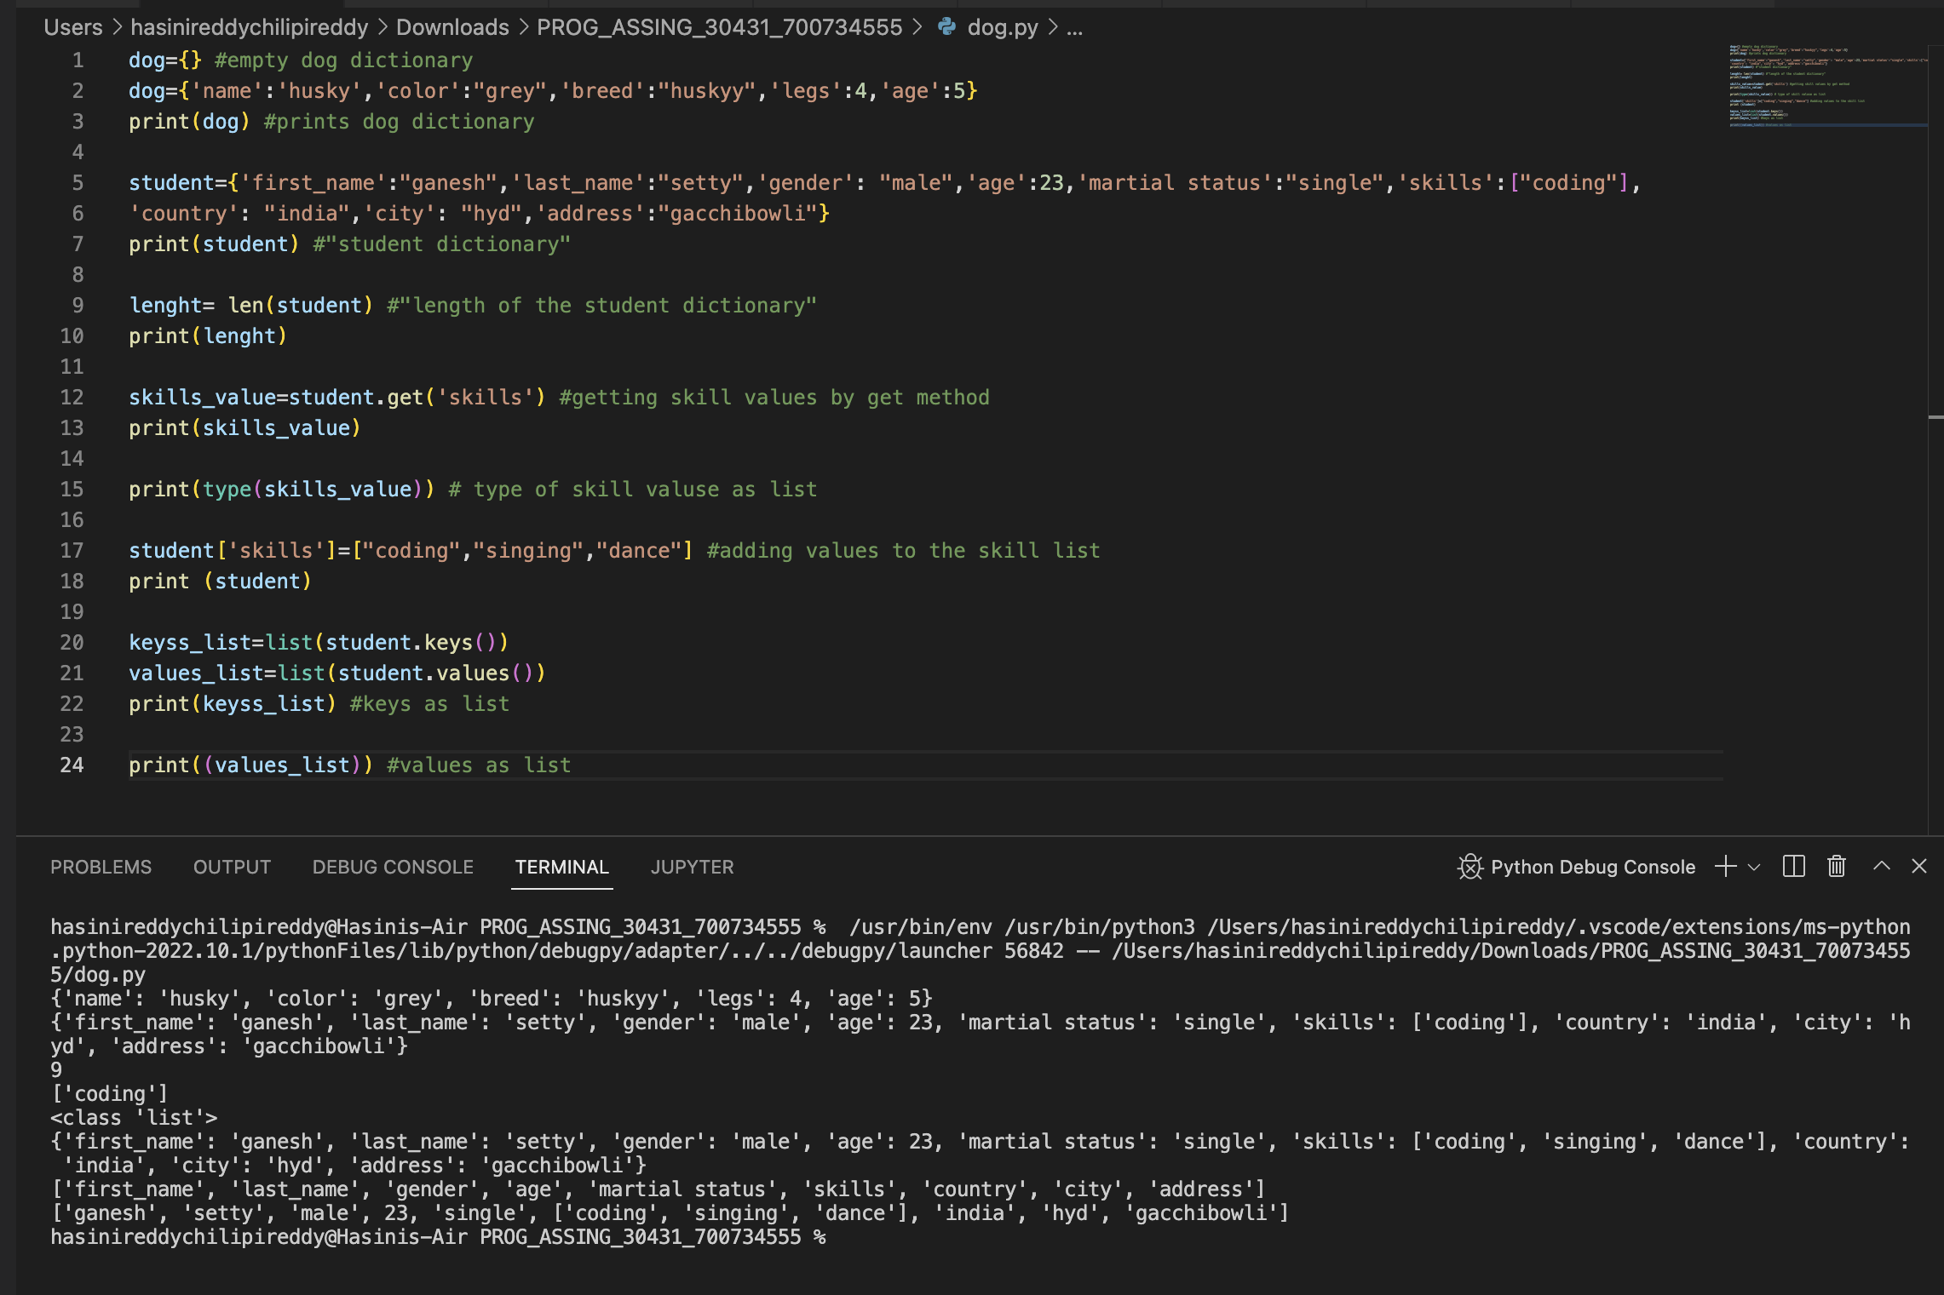

Creating an empty dictionary named dog and adding ‘name' 'color’ ‘breed’ ‘legs’ ‘age.’, creating another dictionary named student and added given keys. By using the (len) keyword we can find the length of the given dictionary. By using (type) keyword we can find the datatype of the given list, we modified the skills values by adding three more skills and printed the dictionary keys as a list and dictionary values as a list.

Q3 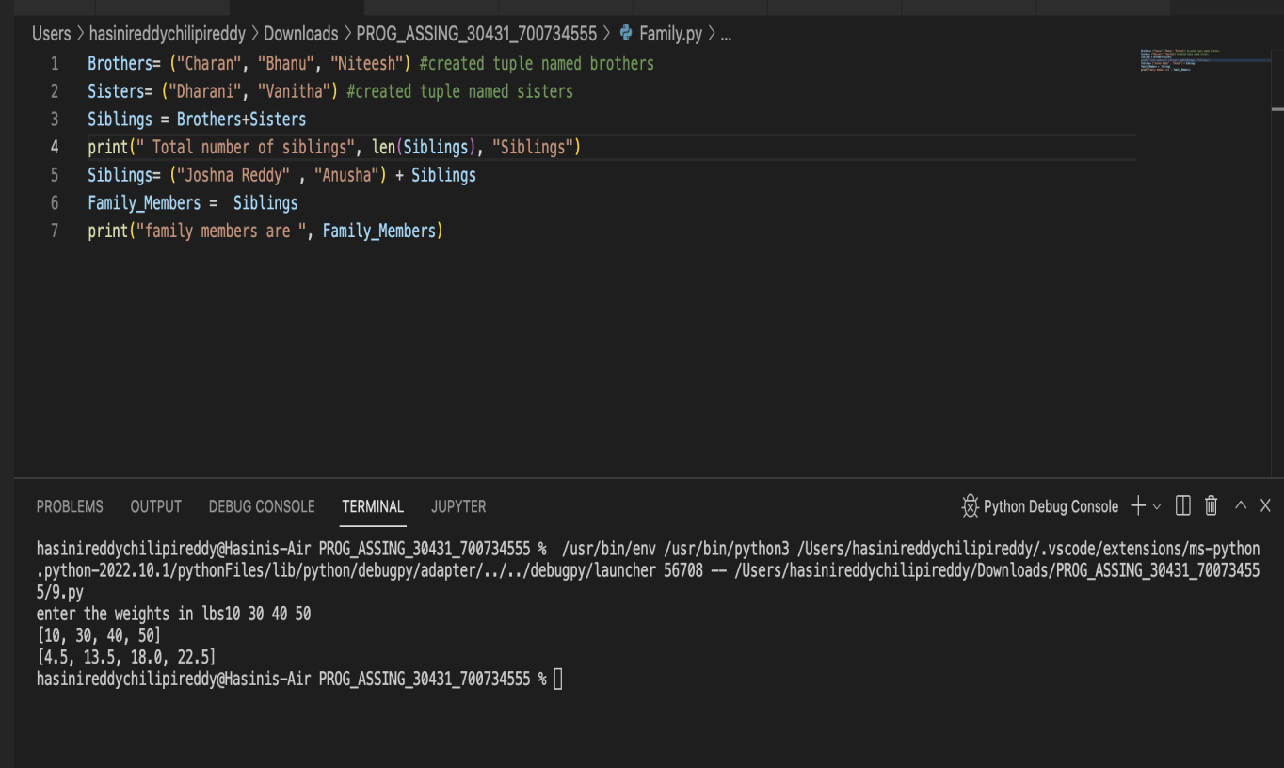

Created two tuples named Brothers and sisters and concatenated using (+) and assigned it to siblings. Finding the length of siblings using keyword (len).

Q4

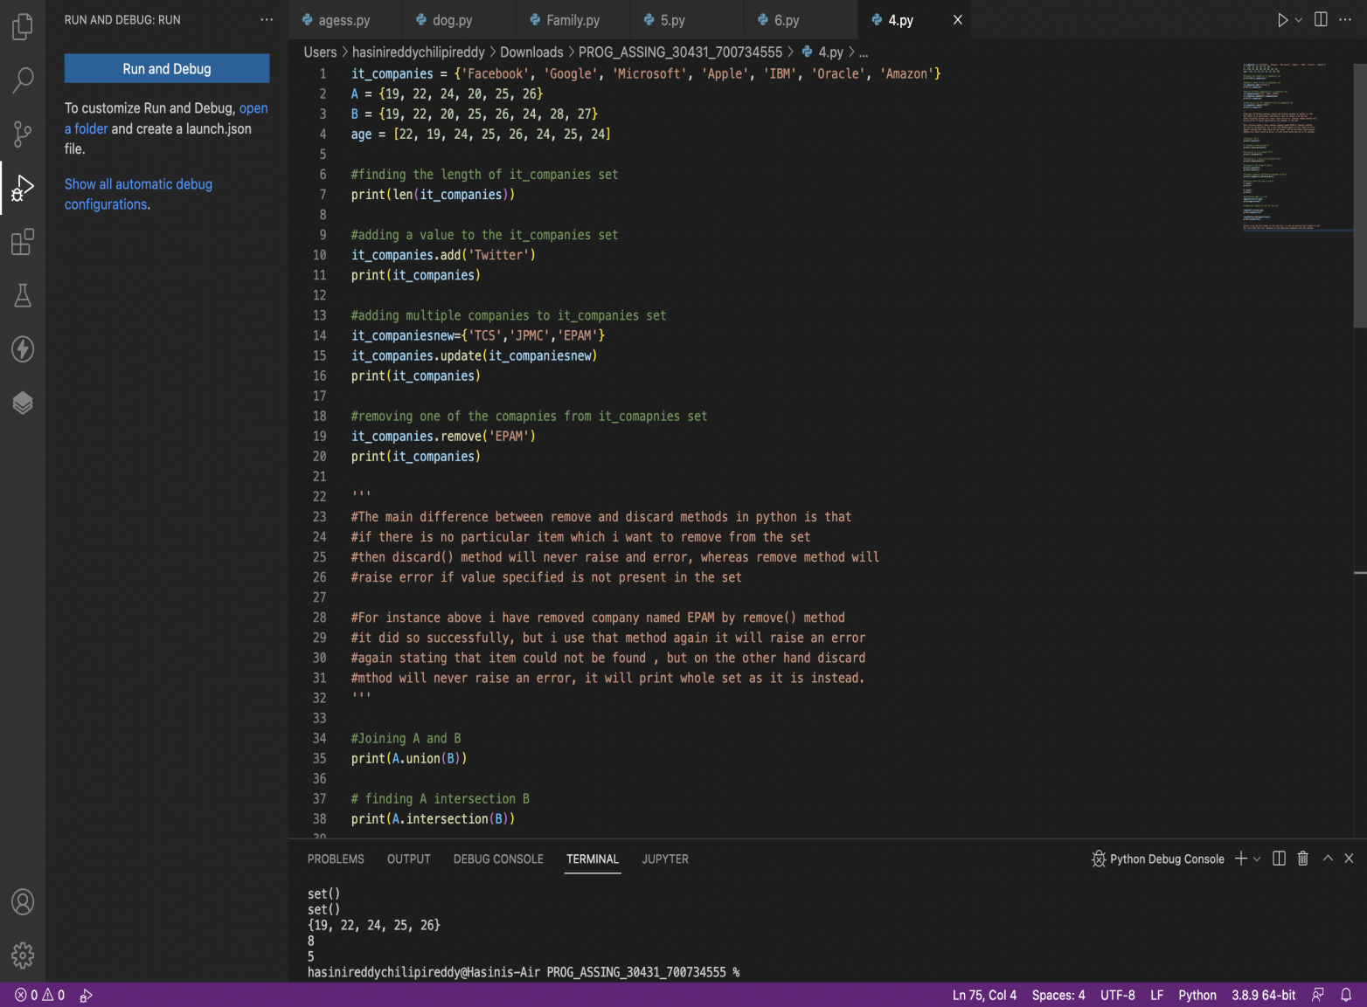

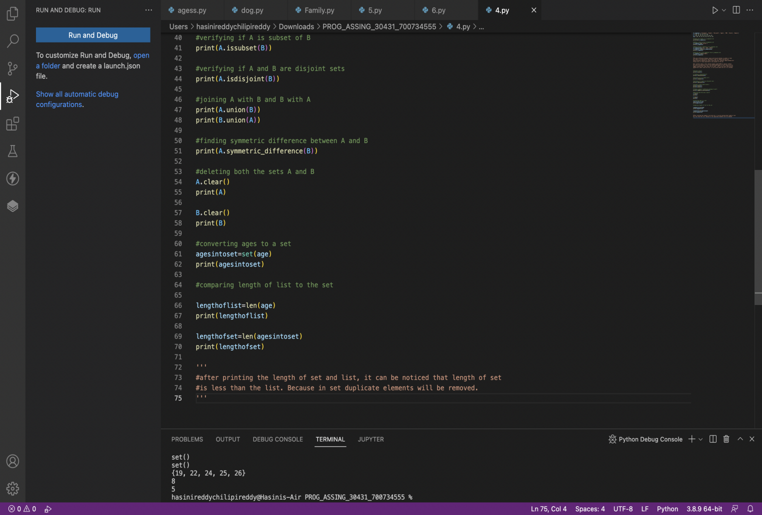

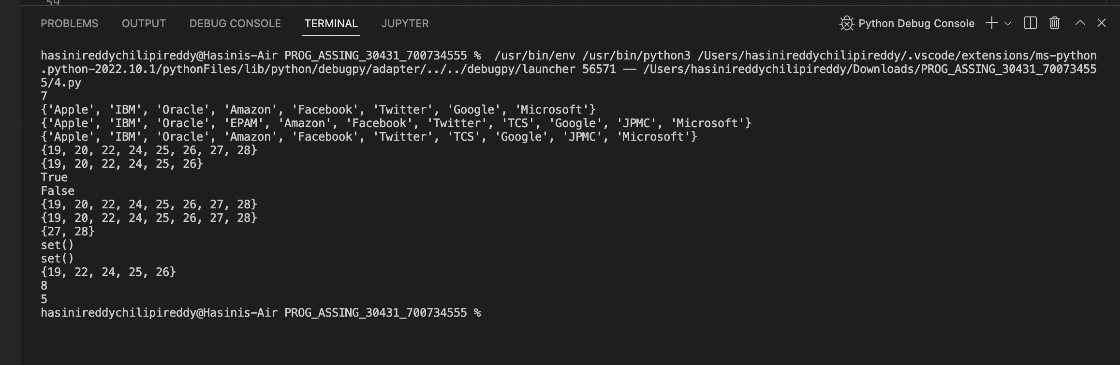

In this question the length of it_companies are found by using (len) key word, adding ‘Twitter’ company using (add) key word, (update) keyword is used to insert new values to the list, and (remove) keyword is used to remove the values from the list. Joining A and B using (Union) keyword and intersection using (intersection) keyword , we have found whether A is subset of B , are A and B are disjoint sets , joining A with B and B with A , delete the sets completely and lastly convert the ages to a set and compare the length of the list and the set .

Q5

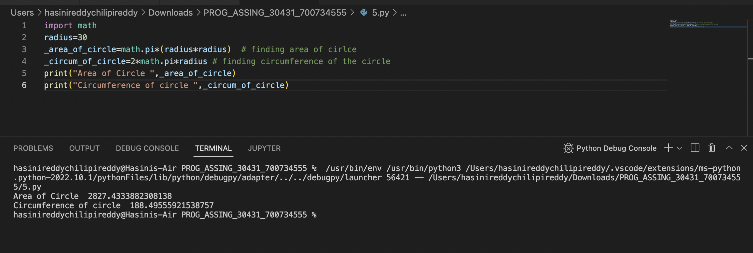

By using math library and with the given radius 30 meters, area of circle (pi *r*r) assigning the value to _area_of_circle and circumference to _cirucm_of_circle.

Q6

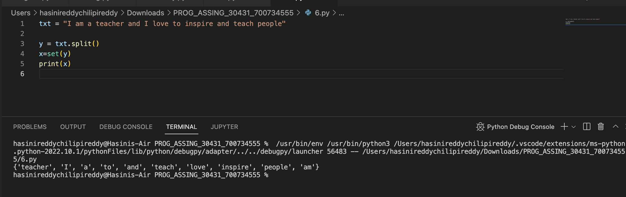

Q7

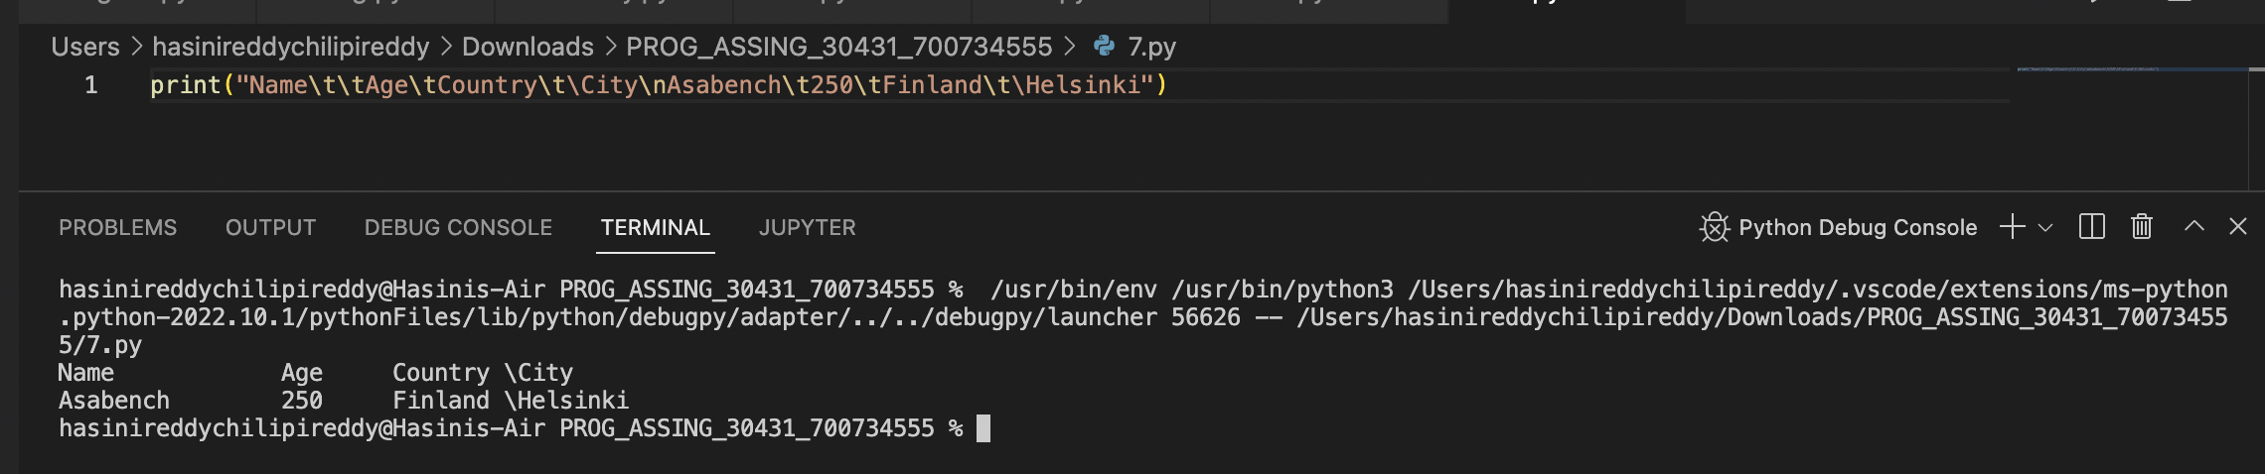

In this question we used tab escape sequence to get the required output.

Q8

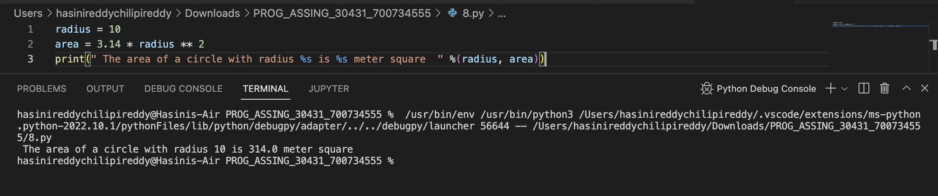

We have found the area of circle with the given radius 10 is 314 meters square.

Q9

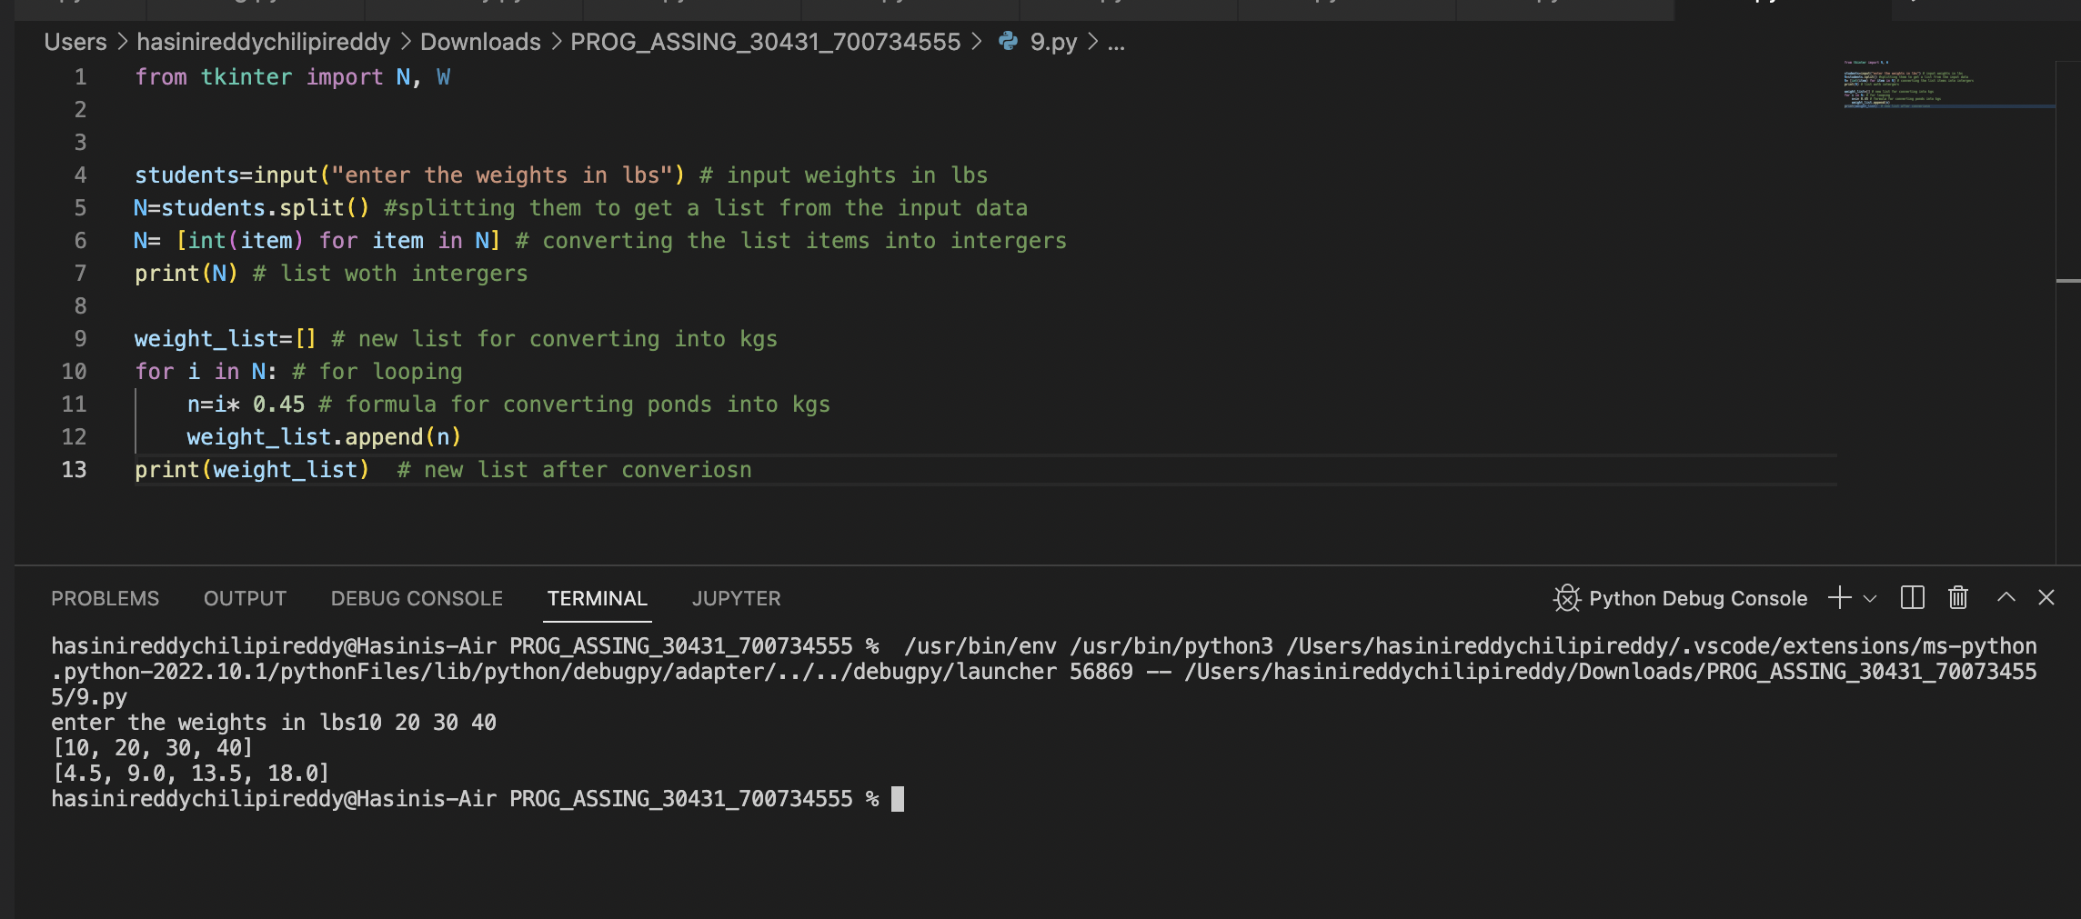

Input() method to take the input from the user.

Split() to split the students list from the input data. The weight in pounds is converted to kilograms using a mathematical operation.

Q10

